

Vulcan Interval Timer Functions

H1 Display: 24hr time format
H2 Display: 12hr time format
Time formats chosen by pressing “clock” button to get desired time format
F Display – work time for interval training
C Display – rest time for interval training
UP Display – count up format
dn Display – count down format
F4 Display – stopwatch format

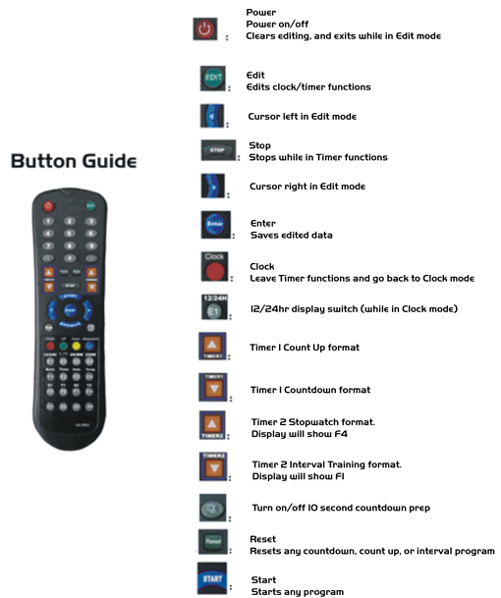

Vulcan Interval Timer Operation

Set Clock:

- Enter into Clock mode, either H1(24hr) 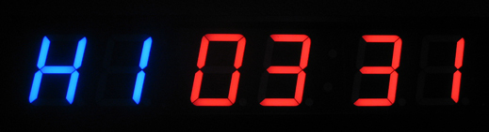
or H2(12hr) 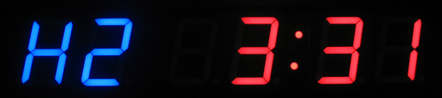, by pressing “clock” button.
- Press “edit”.
- Using cursors and numbers, set time.
- Press “enter”.

Countdown/Up Operation:

Example – 20 minute countdown:
- Press “Timer 1 down” button, or “Down” button. 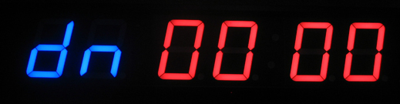
- Press “edit”.
- Input 20:00. 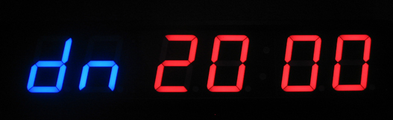
- Press “enter”.
- Press “start” to begin countdown.

Example – 30 minute count up:
- Press “Timer 1 up” button, or “Up” button. 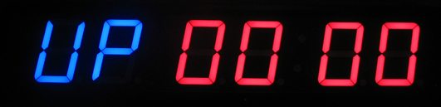
- Press “edit”.
- Input 30:00. 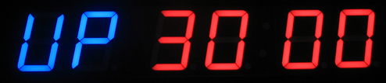
- Press “enter”.
- Press “start” to begin count up.

Saving Countdown/Up Programs

Example – Saving 20 minute countdown program to #1:
- Press “Timer 1 down” button, or “Down” button.
- Press “edit”.
- Input 20:00.
- Press “enter”, then press #1. Clock should beep once indicating program has been saved.
- Now, at any time to enter the 20 minute countdown program automatically, simply press #1, and then “start” to begin.

Example – Saving 30 minute count up program to #2:
- Press “Timer 1 up” button, or “Up” button.
- Press “edit”.
- Input 30:00.
- Press “enter”, then press #2. Clock should beep once indicating program has been saved.
- Now, at any time to enter the 30 minute count up program automatically, simply press #2, and then “start” to begin.

Interval Timer Operation

- Press “Timer 2 down” button. 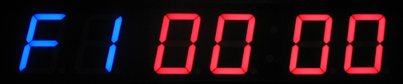
- Press “edit”.
- Input desired work time.
- Press “edit” again to go to Rest mode. 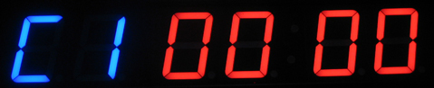
- Input desired rest time.
- Press “edit” again to enter into 2nd interval “F2”.
- Input desired work time.
- Press “edit” again to enter 2nd rest mode “C2”.
- Input desired rest time.
- Continue this method for the desired number of intervals.
- Once the last rest time is put in, press “edit” again, and then “enter” to save the intervals.
- Press “start” to begin the program.
- For “every minute on the minute” type training, simply input 00:00 into the rest “C” modes.
Example – 50 seconds on, 10 seconds off, 40 seconds on, and 15 seconds off program:
- Press “Timer 2 down” button.
- Press “edit”.
- Input 00:50. 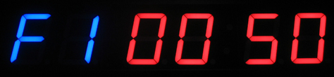
- Press “edit”.
- Input 00:10. 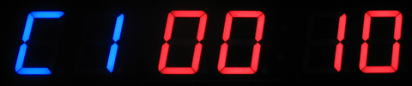
- Press “edit”.
- Input 00:40. 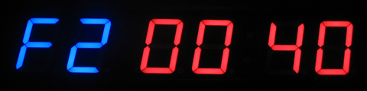
- Press “edit”.
- Input 00:15. 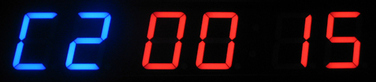
- Press “edit” again, and then “enter” to save the intervals. Clock will display beginning of 1st interval. Press “start” to begin.

Stopwatch Operation

- Press “Timer 2 up” button, or “Stopwatch” button. 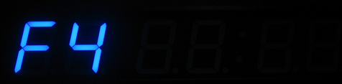
- Press “start”.

Additional Info

Timer has a default 10 second countdown prep.
Voltage is 12V AD. Low voltage will cause abnormal function, and high voltage will ruin the timer.

